Supplemental material

Regulation of DNA nucleases by molecular crowding

Yoshiharu Sasaki, ^{1, 2} Daisuke Miyoshi, ¹ and Naoki Sugimoto^{1, 3*}

¹Frontier Institute for Biomolecular Engineering Research (FIBER), Konan University, 8-9-1 Okamoto, Higashinada-ku, Kobe 658-8501
²Fine Co., Ltd., 5-7-8 Shimoshinjo, Higashiyodogawa-ku, Osaka, 533-0021
³Department of Chemistry, Faculty of Science and Engineering, Konan University, 8-9-1 Okamoto, Higashinada-ku, Kobe 658-8501

* Corresponding author: Naoki Sugimoto
TEL: (078)435-2497, FAX: (078)435-2539, E-mail: sugimoto@konan-u.ac.jp
Table S1 Kinetic parameters of EcoRV, Polymerase I and T7 DNA polymerase in the absence and presence of cosolute.
Enzyme | Cosolute | Concentration | K_{m} | V_{max} | Reference
EcoRV | Ficoll 70 | %(w/v) | (nM) | (μM) | (16)
 |  | 0 | 0.083 ± 0.004 | 10.4 ± 0.1
 |  | 5 | 0.14 ± 0.01 | 14.0 ± 0.7
 |  | 10 | 0.19 ± 0.02 | 15.0 ± 1.0
 |  | 20 | 0.19 ± 0.03 | 15.0 ± 1.0
Polymerase I | PEG 8000 | %(w/v) | (μg/ml) | (U)* | (40)
 |  | 0 | 0.7 | 1.6
 |  | 12 | 0.3 | 1.2
T7 DNA polymerase | PEG 8000 | %(w/v) | (μM) | (μM/min) | (27)
 |  | 0 | 1.04 ± 0.25 | 2.87 ± 0.23
 |  | 5 | 0.72 ± 0.21 | 2.19 ± 0.18
 |  | 10 | 0.66 ± 0.24 | 2.01 ± 0.21
 |  | 15 | 0.51 ± 0.17 | 1.36 ± 0.12
 |  | 20 | 0.41 ± 0.09 | 1.09 ± 0.06
*Units are pmol of thymidylate incorporated in 30 min, normalized to 1 unit of polymerase per ml.

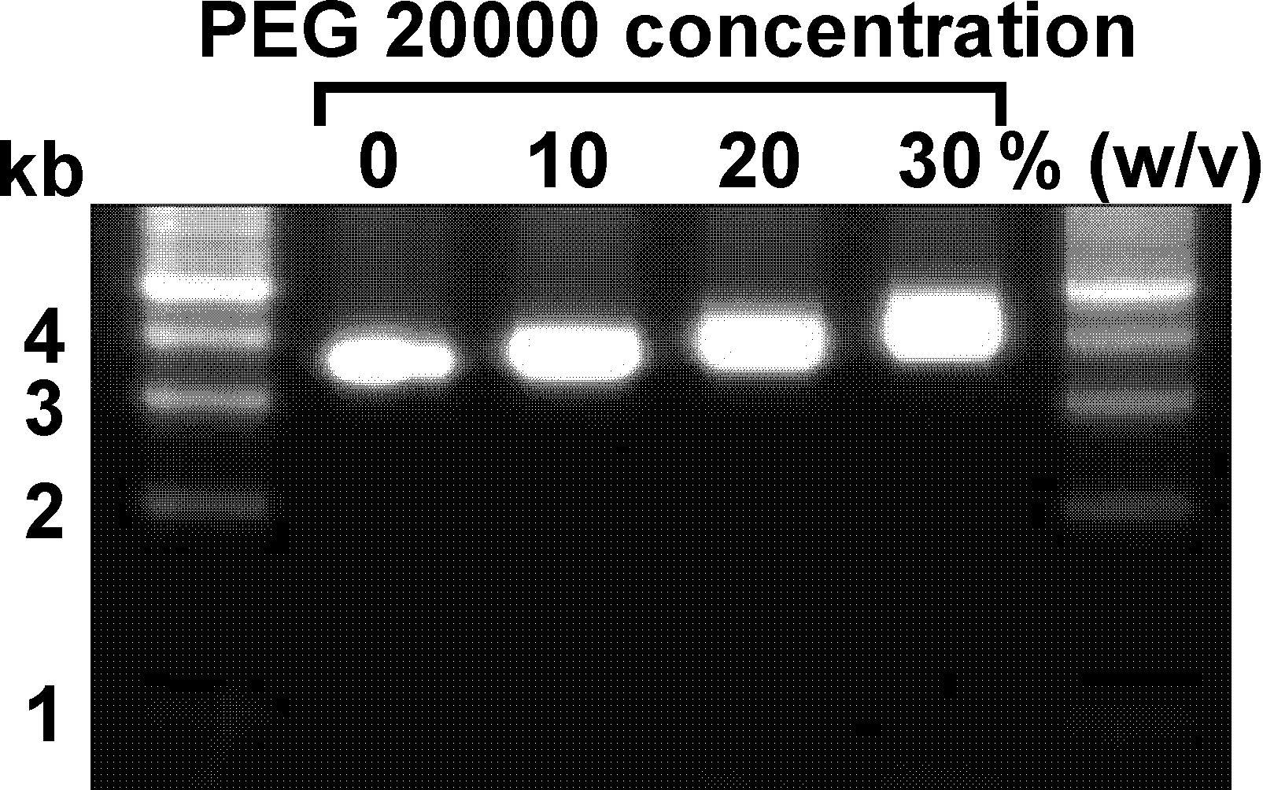

Figure S1. Agarose gel electrophoresis of 0.5 μg plasmid DNA (pcDNA 3.1(+)) in the presence of 0-30% (w/v) PEG 20000. The voltage for the agarose gel electrophoresis was 100 V. The plasmid DNA was visualized by EtBr staining presumably.

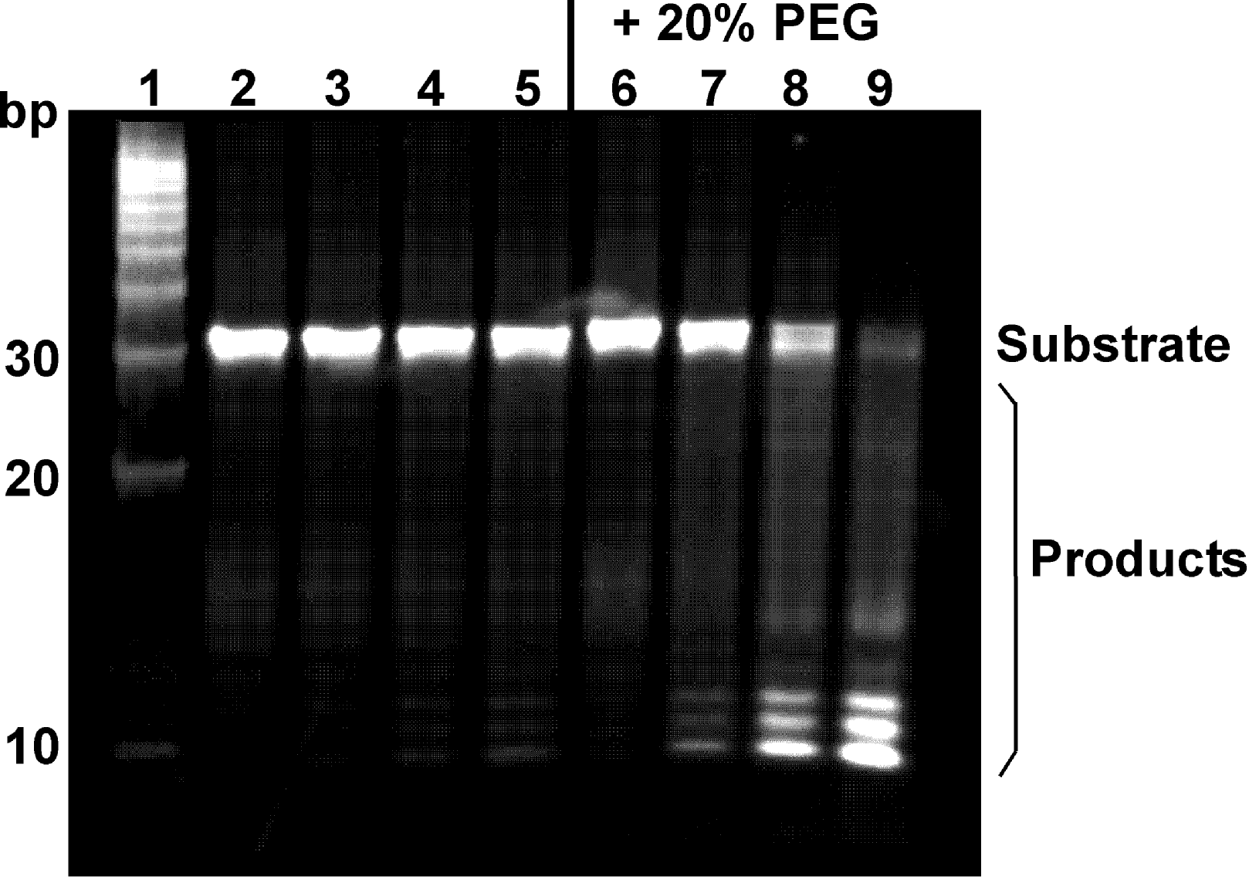

Figure S2. Hydrolysis of a short oligonucleotide DNA (29-mer dsDNA) by DNase I (0.1 U) in the absence or presence of 20% (w/v) PEG 20000 at 25ºC. Lane 1 shows 10 bp DNA ladder. Lanes 2, 3, 4, and 5 show 0, 1, 4, and 10 min, respectively, of hydrolysis by DNase I in the absence of PEG 20000. Lanes 6, 7, 8, and 9 show 0, 1, 4, and 10 min, respectively, of hydrolysis by DNase I in the presence of 20% (w/v) PEG 20000. The temperature for the native PAGE was 4ºC. After electrophoresis, the gel soaked into nucleic acid stain reagent (GelStar Nucleic Acid Stain, Takara, Tokyo, Japan) to visualize the 10 bp DNA ladder.

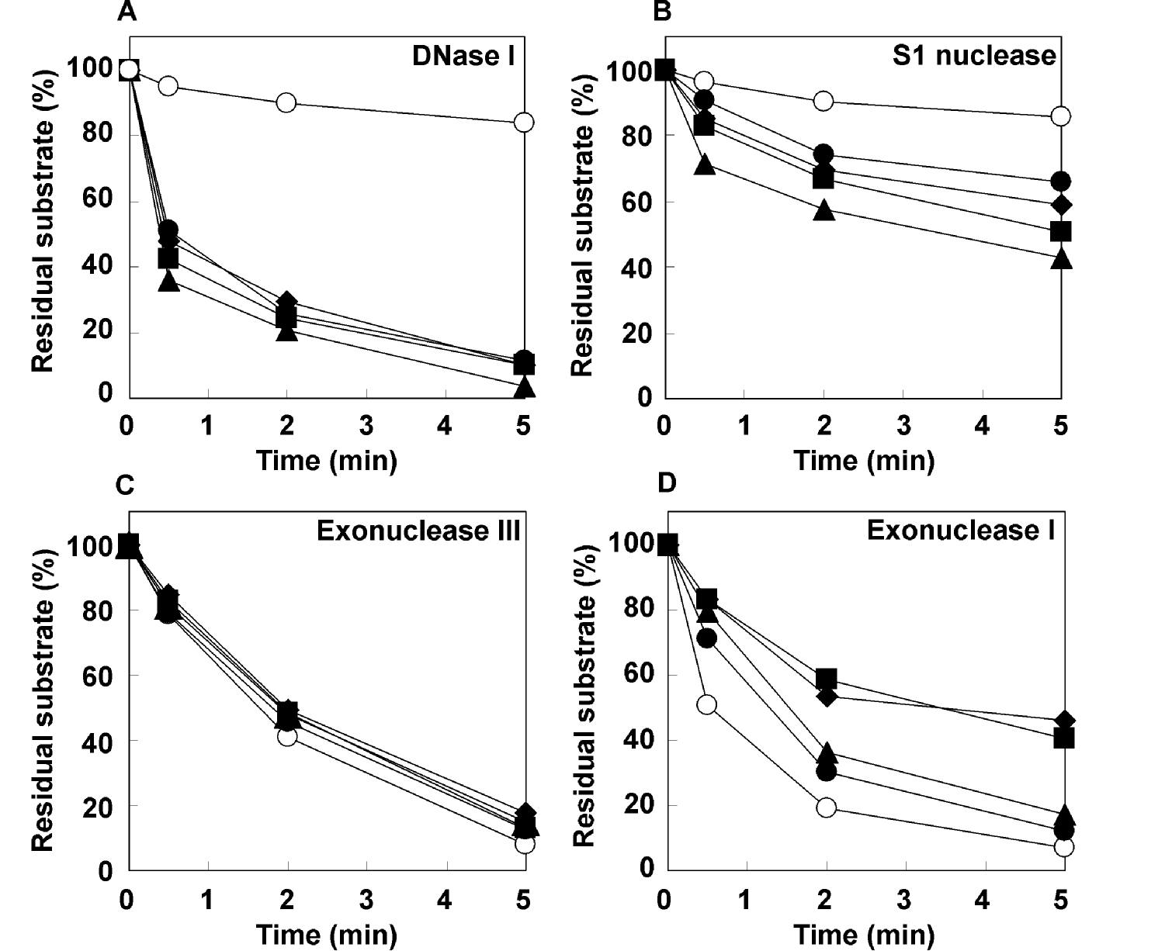

Figure S3. Amount of residual 29 mer dsDNA and ssDNA in the absence (open circles) or presence of 20% (w/v) PEG 200 (closed circles), PEG 4000 (closed triangles), PEG 8000 (closed squares) and PEG 20000 (closed diamonds) and (A) 0.1 U DNase I, (B) 0.15 U S1 nuclease, (C) 1 U exonuclease III, (D) 0.5 U exonuclease I. A ssDNA was used as a substrate for S1 nuclease and exonuclease I and a dsDNA was used as a substrate for DNase I and exonuclease III. Error bars (smaller than 2%) were omitted for clarity.

